EKLAVYA 2023

Scene Graph Generator

## MENTEES:

* Kamakshi Ramamurthy
* Sarvesh Badjugar

## MENTORS:

* Prit Kanadiya
* Raghav Agarwal

About the project:

Detecting objects and their relations in images in the form of a graph data structure and generating graphs to represent relations between objects in a given image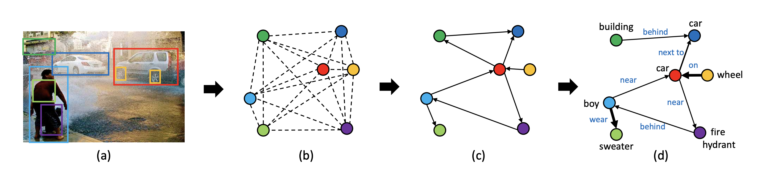

Goals:

* Using the YOLO object detection algorithm to predict the classes of various objects present in the image and the bounding box coordinates for the images.
* Creating a Relationship Proposal Network that takes as input the class of the object and its bounding box coordinates and outputs subject-object pairs for establishing relations.
* Using an Attention Graph Convolutional Neural Network to establish concrete relations in the form of subject-relationship-object- object as a graph between the objects having relationships.

IMPLEMENTING YOLO (you only look once) :

We have used YOLO v3 to implement our object detection part of the model. Although most scene graph generators are based on fast-RCNNs, we prefer YOLO . Our model has several advantages over classifier-based systems. It looks at the whole image at test time so its predictions are informed by global context in the image. It also makes predictions with a single network evaluation unlike systems like [R-CNN](https://github.com/rbgirshick/rcnn) which require thousands for a single image. This makes it extremely fast, more than 1000x faster than R-CNN and 100x faster than [Fast R-CNN](https://github.com/rbgirshick/fast-rcnn).

We are using Darknet’s yolo v3 for our project due to its high accuracy on coco classes.

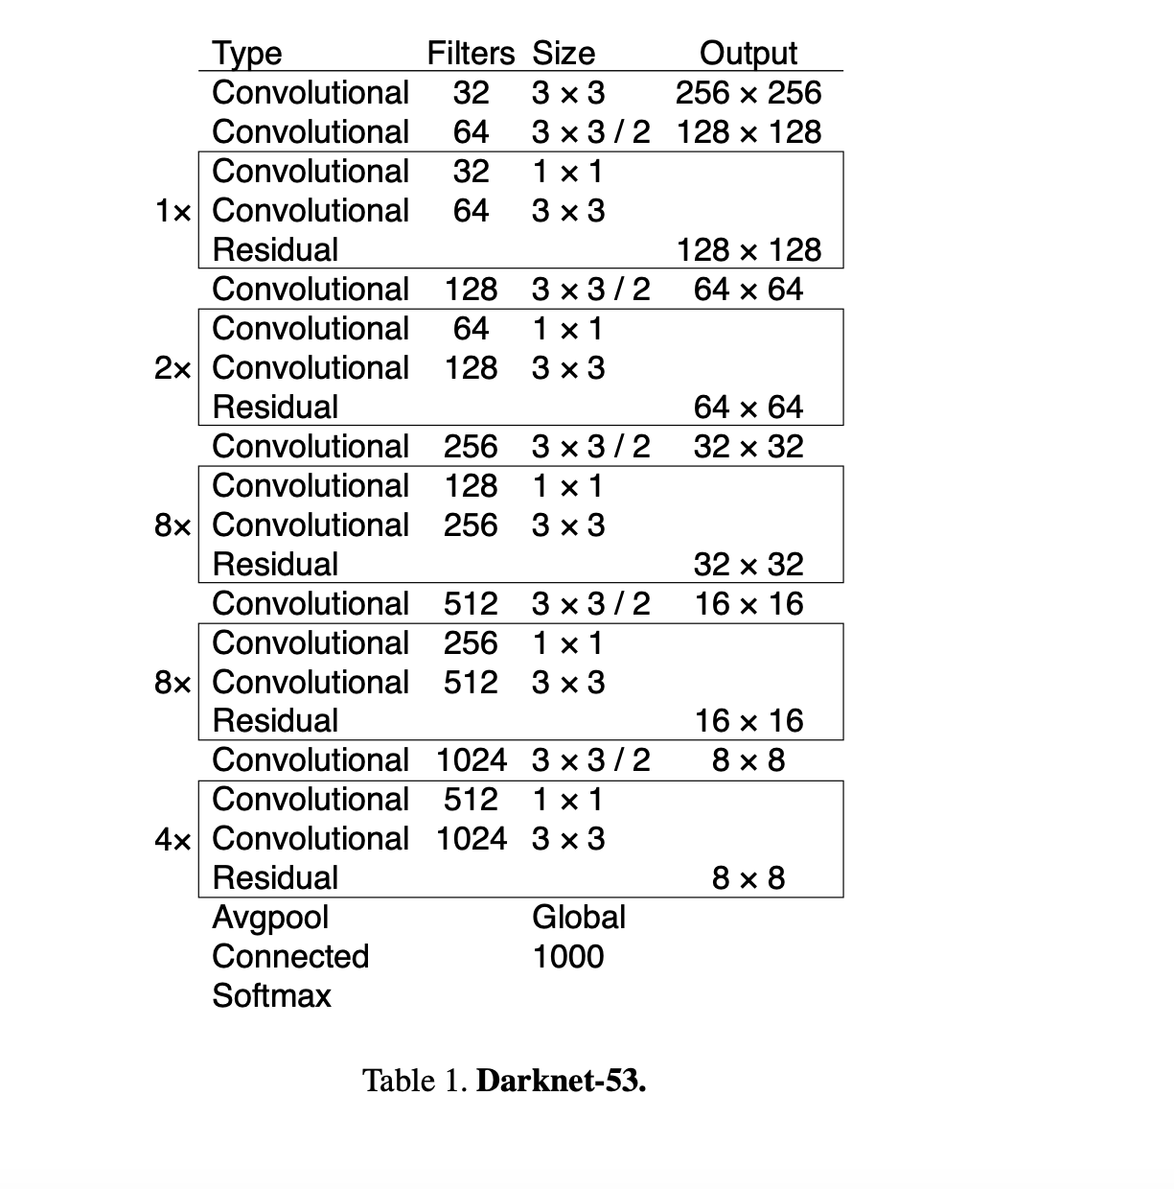

How does YOLO work?

Image classification and localisation:

* using a ConvNet we can detect multiple types of objects in an image. The output gives us the probability of the object, the class it belongs to and the bounding box coordinates. We can detect objects using sliding windows with convolutional implementation. However, none of the windows for a perfect bounding box. This can be solved by YOLO.
* We place a grid on the input image and apply image classification and localisation algorithm to each grid box.
* For training we specify a label Y which is a n dimensional vector: probability of object, probability it belongs to a class and the 4 bounding box coordinates.
* We then use IOU to find intersection between actual and ideal bounding box.
* If the same object is detected multiple times, by non max suppression the most confident detections are taken. Then the non max suppression looks at the remaining windows and the ones with high IOU get suppressed.
* If 2 objects have the same midpoint then the output vector won’t be able to detect both . Therefore we implement the concept of anchor boxes. The idea is that we assign a particular box shape to each prediction.

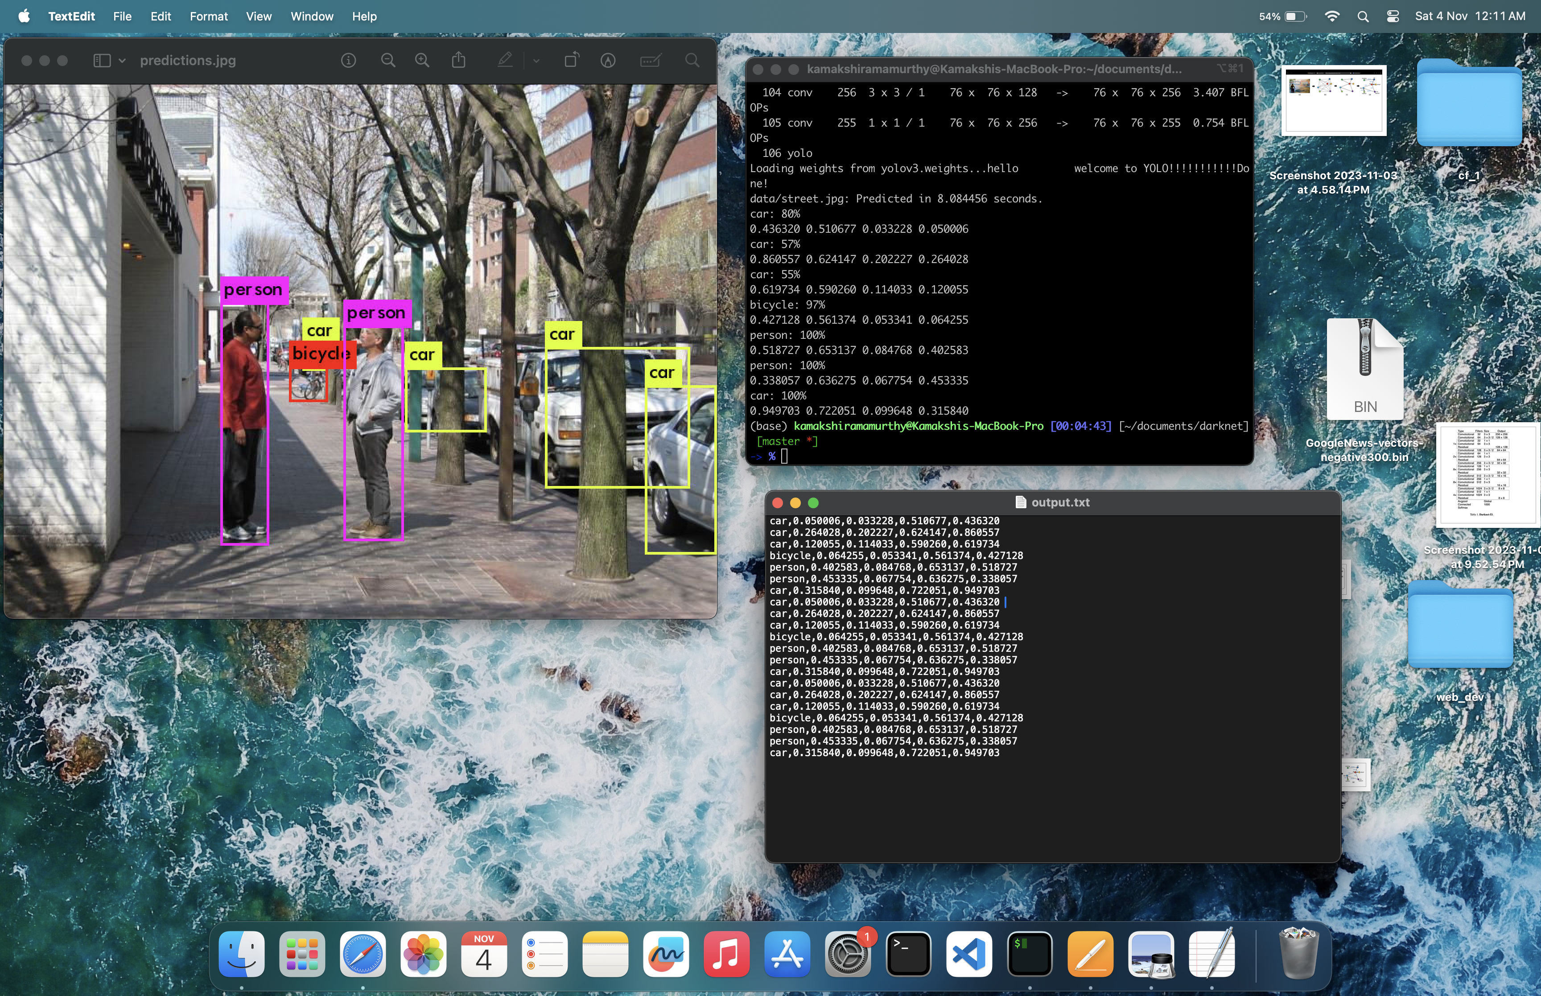

We store the output class name and bounding box coordinates to feed to the RePN

Relationship Proposal Network

If their are n objects detected in an image then the possible pairs that can be generated would be n*(n-1).

If we try to compare the time complexity of each object with the other the time complexity would be O(n^2). Instead we use attention mechanism to reduce the time complexity .

For the object classes we use word to veg embeddings which output a 300x1 matrix to this we add the 4 bounding box coordinates to get a matrix of 304x1. We use the retrained GoogleNews embeddings for the same.

We have then created 2 identical key and query neural networks which input a 304xn matrix where n is no of objects and 304 is the 300 x1 word2vec embeddings for the object class and 4 bounding box coordinates.

The first and second layer has 256 as output and the final matrix will be a 128xn matrix. We will obtain 2 such matrices : one from key and one from query.

We multiply the key with transpose of query and apply sigmoid to get an attention matrix as output.

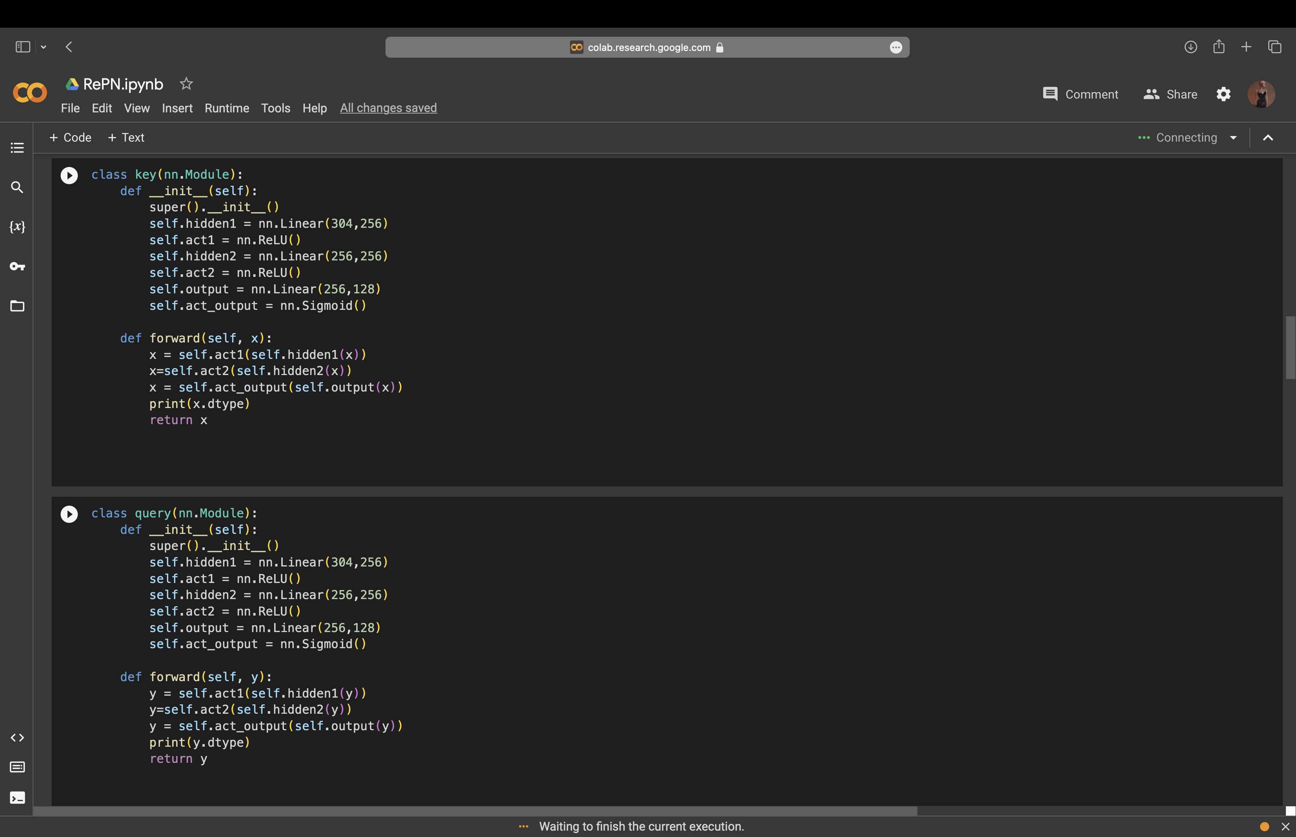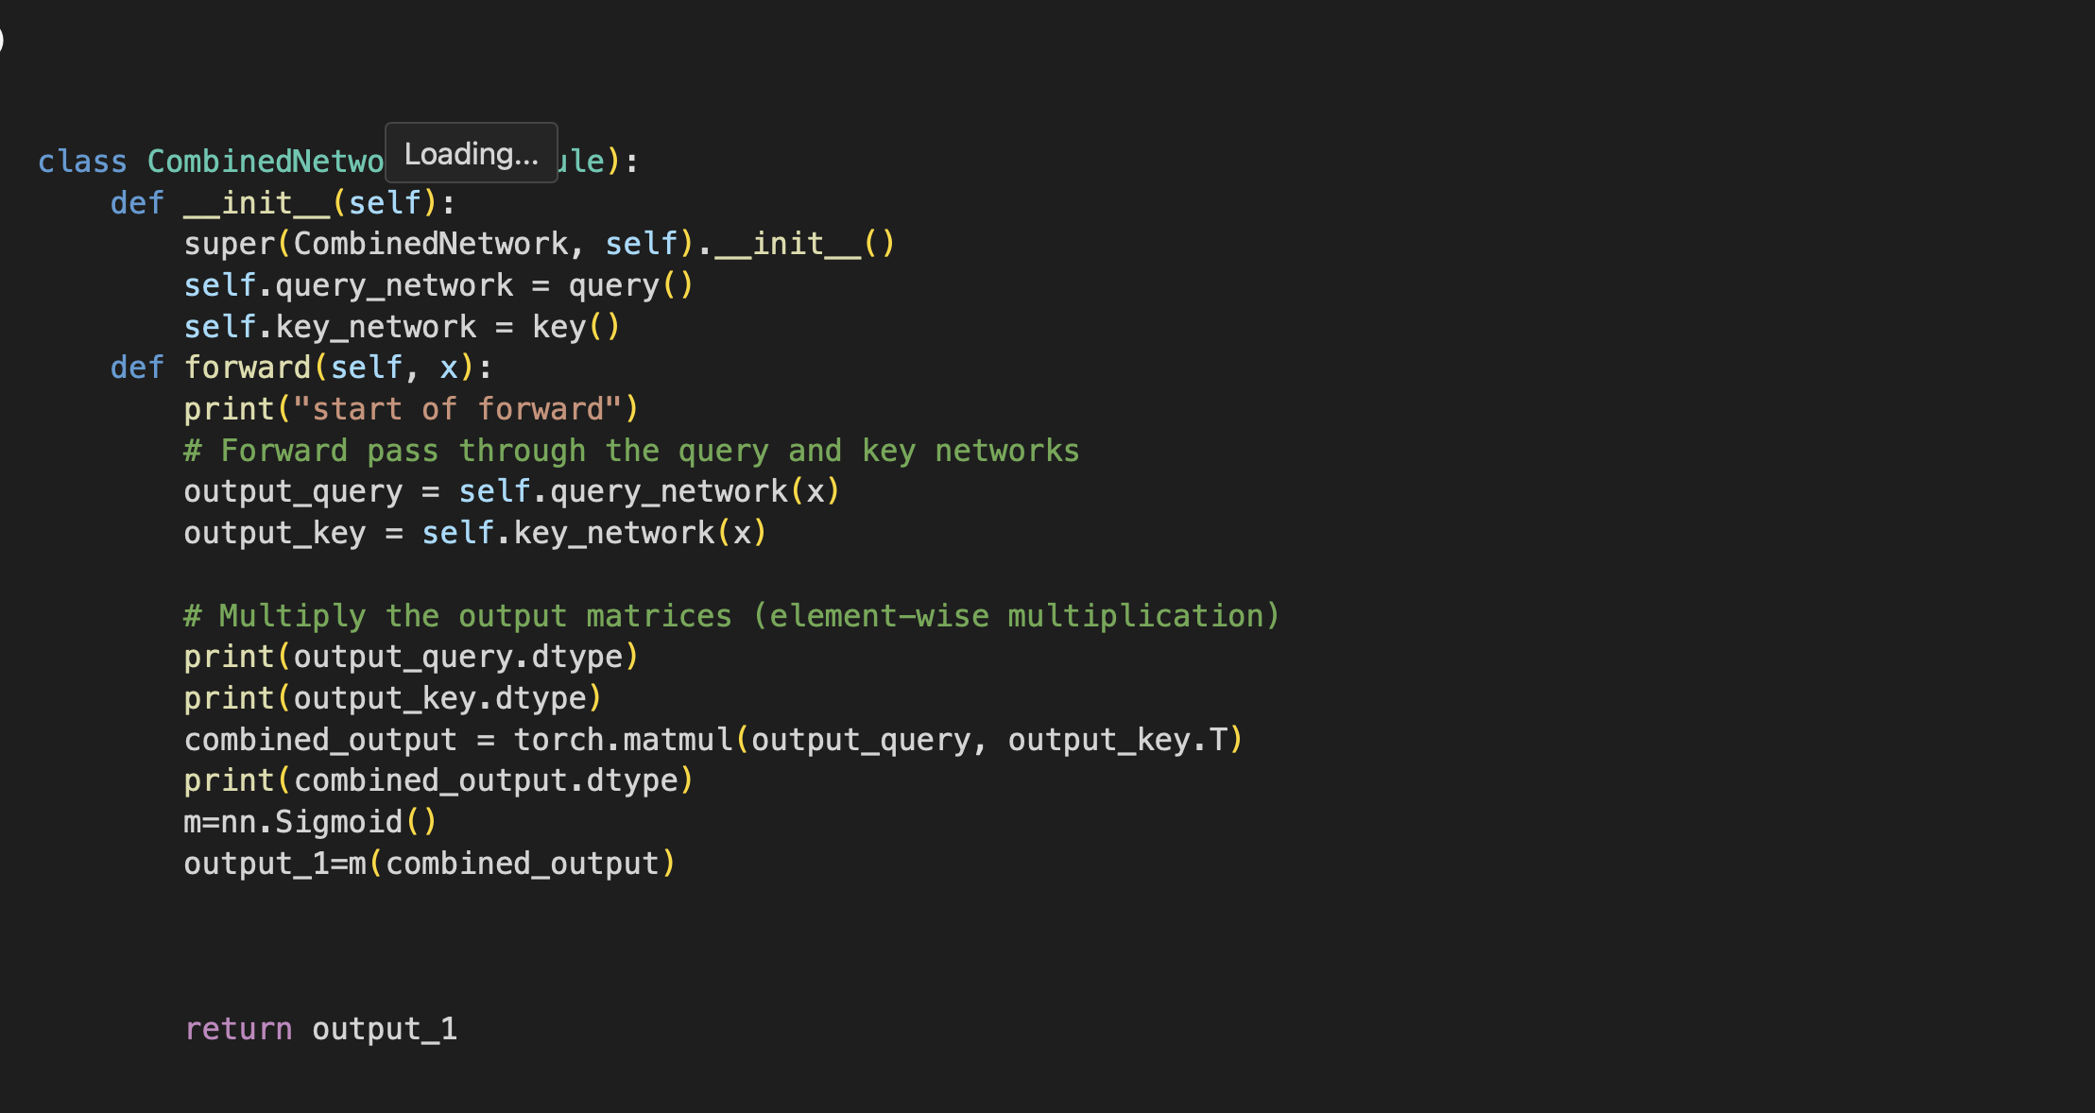

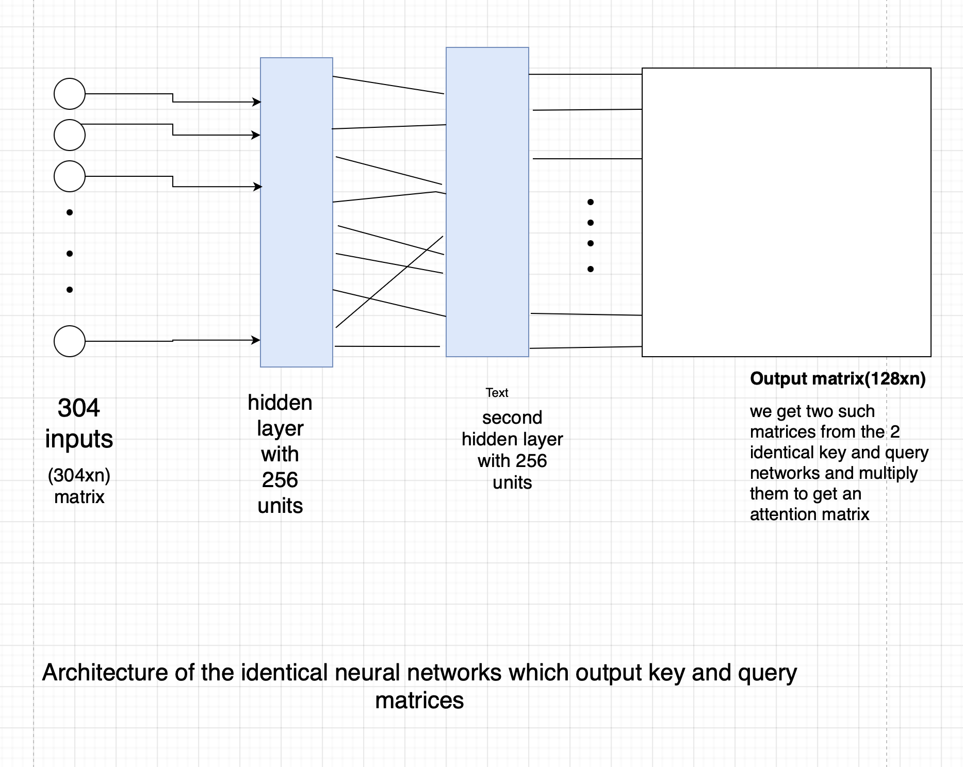

Training:

For training we will be using the visual genome dataset based on coco classes with 108077 images and their relationships described.

We create a relationship matrix with one at places with objects at row and column having relationship and 0 for those who don’t. This is used as labels in training.

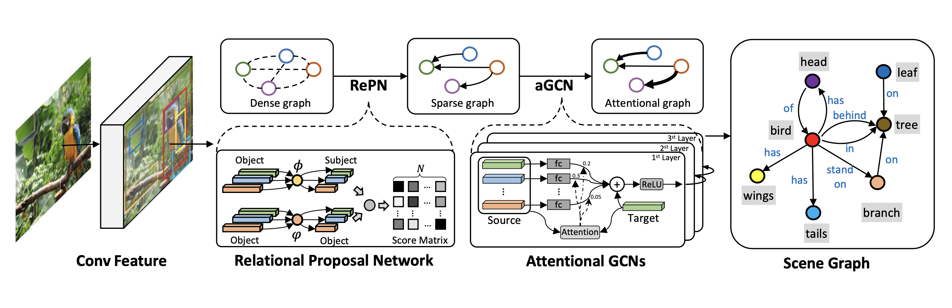

Future work:

aGCN for Scene Graph Generation.

Recall that from the previous sections we have a set of N object regions and m relationships. From these, we construct a graph G with nodes corresponding to object and relationship proposals. We insert edges between relation nodes and their associated objects. We also add skip-connect edges directly between all object nodes. These connections allow information to flow directly between object nodes. Recent work has shown that reasoning about object correlation can improve detection performance [10]. We apply aGCN to this graph to update object and relationship representations based on global context.

Note that our graph captures a number of different types of connections (i.e.object ↔ relationship, relationship ↔ subject and object ↔ object). In addition, the information flow across each connection may be asymmetric ( the informativeness of subject on relationship might be quite different from relationship to subject).

Testing on better YOLO and other object detection algorithms

We further aim to use other versions of yolo also other object detection algorithms to test the models accuracy

